Restaurant Management System

Project Task on Business Analysis

Q1) Identifying Stakeholders – Create a list of Stakeholders (as taught in Business Analysis Planning and Monitoring Knowledge Area)

Ans) The list of the Stakeholders are as follows:

1. Grill House Manager-responsible for entering the bills,total sales analysis and item wise sales

Analysis for the day

1. Grill House Waiters-responsible for serving dishes to the customers
2. James Oliver(CEO of Grill House)-responsible for changing the manual system in automated one so that the menu updation becomes easy
3. Grill House Customers-are the male,female and children who are using the food of Manual Restaurant System
4. Grill House Management-responsible for total sales analysis day and month wise

Q2) Create As-Is and Future Process map (using flowcharts). You can use any of the popular tools in the market like Microsoft Visio, Lucidchart, Creately, Pidoco, or Balsamiq

Ans) The flowchart of Manual Library System is as follows:

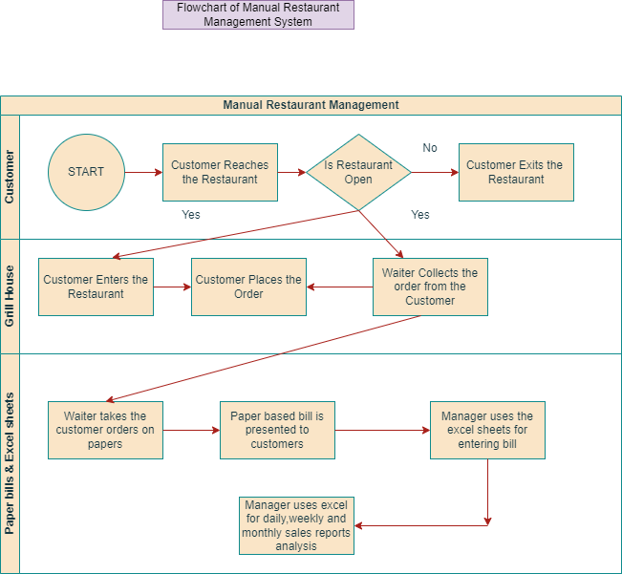

The above mentioned is the swimlane diagram of Manual Restaurant Management

The flowchart of Automated Library Management System is as follows:

The below mentioned is the swimlane diagram of Automated Library Management System

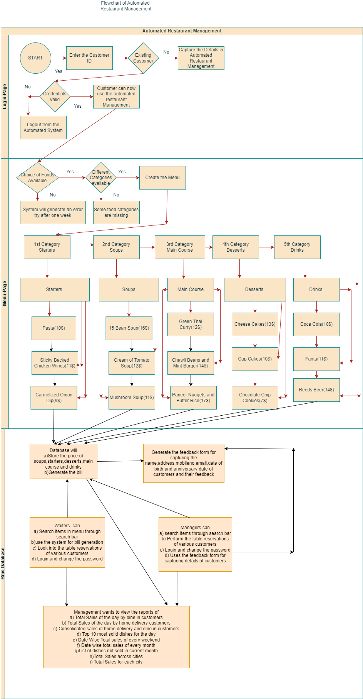

Q3) As a Business Analyst working on this project, find out the scope of the Restaurant Management Software. Write down the main features that need to be developed.

Ans) **Scope of the Restaurant Management System**

Scope of the Restaurant Management System are the boundaries of the Restaurant Management

System. Scope Modelling is one of the acceptance criteria. Scope Modelling can be in scope or

Outscope

Examples of In-Scope Restaurant Management System is as follows:

1. Grill House Restaurant uses the paper based system
2. The orders in Grill House are taken on papers by the waiters
3. The Grill House gives the paper bill to its customers
4. Manager of Grill House uses an excel sheet for entering bills.The excel sheet has table of daily,weekly and monthly sales of Grill House
5. For viewing the most popular and the least popular dishes,the management of Restaurant system use excel sheet as their tracker

The main features that needs to be developed is as follows:

1. The new automated Restaurant Management system must capture the login details of the existing and new customers in their database
2. The user interface of Restaurant Management system must have login window of username and password
3. Once the user logs in to automated system a detailed view of menu must be visible to the user.
4. The menu of Restaurant Management shall be divided into Starter,Soups,Main Course,Desserts and Drink Sections.
5. These sections of Starter,Soups etc must be divided into various sub categories along with their prices
6. Their must one database for storing the price of soups,starters,main course and drinks
7. Their must be one search bar inside menu page of Automated Restaurant Management where the waiters and managers can search the items through search bar.
8. Their must be a separate column of viewing the bills of various customers in the automated Restaurant Management System
9. Their must be separate column or drop down of table reservations entry. Only the Managers of Grill House should have access of entering and modifying the records of the existing and new customers of Grill House
10. Their must be a button inside the database which will generate the feedback form.Database must generate the feedback form which can be use further for capturing the details of the customers of Grill House
11. Their should be a separate tab or section of Reports View. On clicking on Reports view,it should display the following lists to Management. The lists in the reports view tab is listed below:

1)Total Sales of the day by dine in customers

2)Total Sales of the day by home delivery customers

3)Total sales of the day (home delivery and dine in customers consolidated)

4) Top 10 most solid dishes for the day

5) Total Sales every weekend by inputing the dates

6) Date wise view of Total Sales of every month

7)The list of dishes which are not sold in the current month

8) Total Sales across all cities

9) Total Sales for each city

Q4) Write the in-scope and out-of-scope items for this software.

Ans) **In-Scope requirements** of the software are the requirements which lie inside the boundary

While out-scope requirements of the software are the requirements which lie outside the boundary

Some of the In-Scope and Out-Scope requirements are listed below:

In-Scope Requirements

1. Only USA citizens can order food through Automated Restaurant Management Software of Grill House
2. The web page of automated restaurant Management must contains the menu tab which has following sections in a drop down ie Starters,Soups,Main Course,Desserts and Drinks along with the price tags in dollar notation
3. Waiters of Grill House can only use the software for bill generation while managers can use this software for menu updation,table reservation,feedback form submission and menu search navigation
4. Only the Management of Grill House USA can view the report formats of Total Sales of the day by dine in customers,Total Sales of the day by home delivery customers,Consolidated reports of Total Sales by home delivery and dine in customers,The top 10 most solid dishes,date wise view of total sales in every weekend,date wise view of total sales in every month,Dishes which are not sold in current month,Total sales across all cities and for each city
5. The change Password facility of Automated Restaurant Management is given to Waiters and Managers of Grill House USA
6. James Oliver(CEO of Grill House) also have the change password facility access

**Out-Scope Requirements**

1. Apart from USA citizens,no other citizens of any country can use this Automated Restaurant Management Software
2. If the Managers and waiters of other restaurant are using the Automated Software except Grill House,then it comes under Out of Scope Requirement. The access of software is limited to only Managers and Waiters of Grill House USA only
3. If any alternate CEO except James Oliver is using the software,then it also comes under Out-of scope requirement
4. If the report section of Automated Software is visible to any alternate management except Grill House One,then it is also a part of Out of Scope requirement. The reports section of automated Restaurant Management is visible to only Grill House Management

Q5) Write out the business requirements, both functional and non-functional requirements.

Ans) **Functional Requirements**: are the requirements which must be present in the product. These are the functions which developer must enable to accomplish their tasks

Some of the functional requirements of automated restaurant Management are listed below:

1. The home page of Automated Restaurant Management must contains the label of username and password. The textboxes must be assigned to username and password fields and there has to be one submit and reset button for capturing and erasing the user details from the assigned textboxes.When the user clicks on the submit button,the menu tab must appears on the top of the page in the software
2. When the user clicks on the menu tab, a detailed drop down should appear which contains the items ie Starters,Soups,Main Course,Desserts and Drinks serial wise. The items ie Starters,Soups,Main Course,Desserts and Drinks must be classified into various categories along with the price tags.The Price tags of these categories must be stored in the database

1. Database of the Automated System must generate the bills .There should be a separate column of viewing the bills/Bill Generation which is accessible to both managers and waiters.Their must be a separate section of viewing reports in the software. When the user(Restaurant Management only) clicks on viewing reports tab a detailed drop down must appear which contains the following lists ie:
2. Total Sales of the day by dine in customers 2) Total Sales of the day by home delivery customers 3) Consolidated report of total sales of the day by home delivery and dine in customers 4) The top 10 most solid dishes for the day 5) Date wise view of total sales in every weekend 6) Date wise view of total sales in every month 7) List of dishes which are not sold in current month 8) Total sales across all cities and for each city
3. The password facility change access must be given to waiters and Managers of Grill House USA as well as to James Oliver(CEO of Grill House)
4. The automated Restaurant Management System must have one payment gateway for accepting the payments from Customers of Grill House either by cash or card

**Non-Functional Requirements**: are the quality of the system. These are the Quality attributes. These are basically the support features

Some of the Non-Functional Requirements are:

1. Availability: The automated software is available for Grill House USA Citizens
2. Compatibility: The software must handle the registration of citizens living in various cities of USA
3. Usability: The software is easy to use for U.S.A natives
4. Security: The automated Restaurant Management system can handle threats, viruses and malicious attacks
5. Localization: The UI(user-interface) of the software is designed in English Language and the price of items are mentioned in dollars
6. Extensibility: The software can incorporate the new features according to the Stakeholders requirements
7. Compliance: Only USA citizens can use the automated Restaurant Management system. No outsider or citizen of another country can use the system because it will ask for the some specific credentials
8. Portability: The USA employees can access the automated software on every desks.It must be portable and handy

Q6) Draw wireframes or mock screens for two of the features namely menu creation and table reservation. Use the technique prototyping or wireframing that is taught in the training. You can use any of the wireframing tools like Microsoft PowerPoint, Microsoft Word, Balsamiq, Sketch, Adobe XD, Adobe ILLustrator, Figma, UXPin, InVision Studio, Invision Freehand, or Moqups.

Ans) The wireframe of Menu Creation of Automated Restaurant Management System is mention below:

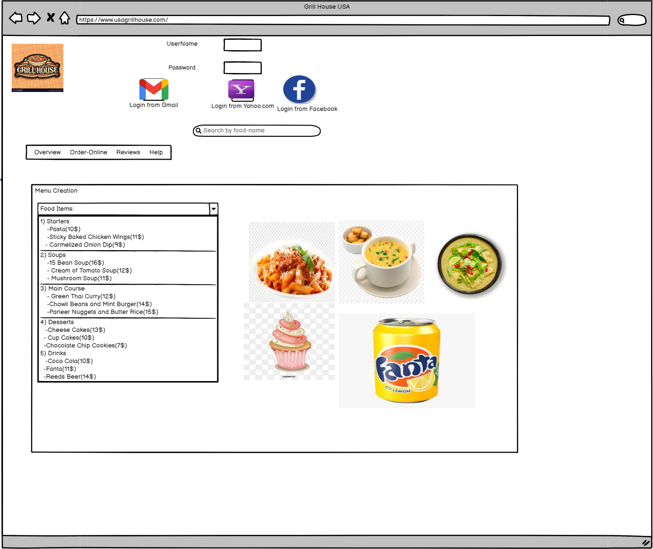

The wireframe of table reservation is mention below

